MATTRIX MODERN SCHOOL

**WELCOME NOTE 01.04.2025**

Dear Parents,

Please accept our warmest greetings. With immense pleasure we welcome your child to our new academic session 2025-26. We would like to inform that we are committed to providing a caring, supportive learning environment where every child is guided and encouraged to become an independent learner, fulfilling their potential in all areas of their learning.

Our theme for this year is: **Promoting Excellence through Determination and Hard work**. We asked you to guide and support your child’s learning by ensuring that he/she:

* Attends school daily and arrives on time, ready for the day’s learning experience
* Completes all homework, assignments given by teachers
* Practices Reading daily to develop interest in reading and to improve literacy skills and vocabulary.
* Shares school’s experiences with you so that you are aware of his/her school life
* Informs you if he/she needs additional support in any area or subject

**We have introduced more interesting and organized teaching pedagogies to ensure**  **Quality Teaching**. Some of the changes are:

* Arrangement of Remedial Teaching on alternative Saturdays, which is separated from our normal teaching hour .
* Achievements of Deep Learning in all subjects using digital media platform.
* To generate students’ interest in Mathematics in both Primary and Secondary level.
* To promote excellent writing and reading skills across Primary and Secondary level.
* We are introducing SPaG (Spelling Punctuation and Grammar) as part of our English Lessons. Extra classes for spoken English and self-grooming.
* ‘Every Child Matters’ agenda and support for the children with learning difficulties.
* A keen sense of discipline will be inculcated in all children and staff
* Weekly monitoring of children’s daily work within stipulated time.
* We have recruited some experienced and outstanding teachers to join our team.

We are happy to inform you about the significant success in the conclusive results of the 2024 CBSE Secondary & Sr. Secondary Examinations. This came because of numerous interventions, teamwork and diligence by staff. It is hoped that this standard will not only be maintained but improved upon as we promote and celebrate excellence through determination and hard work.

The progress of the school as well as your child depends on large measures on the active cooperation between parents and the school. Hence we look forward to a positive and productive year together.

**New session begins on 09.04.2025 for classes IV-X & XII (All Streams) & 21.04.2025 for classes XI (All Streams)**

**Morning Section – Classes IV, V, XII (All Streams) & XI (Science)**

**Reporting Time: 8.00 AM. Assembly : 8.10 AM Dispersal: 12.00 pm**

**Day Section – Classes VI- X & XI (Arts & Commerce)**

**Reporting Time: 11:25 A.M. : VI, VII, VIII & 12:00 P.M. : IX, X, XI ARTS & COM**

**Assembly: 12:10 P.M. Dispersal: 3:35 P.M.**

**BOOKS DISTRIBUTION**

**DATES: 03.04.2025 (THURSDAY) & 04.04.2025 (FRIDAY) TIME : 9.30 AM to 1 PM & 2 PM to 3.30 PM**

**N.B. You are requested to pay the fees and other charges for the New Session 2025-26 by 4th April 2025.**

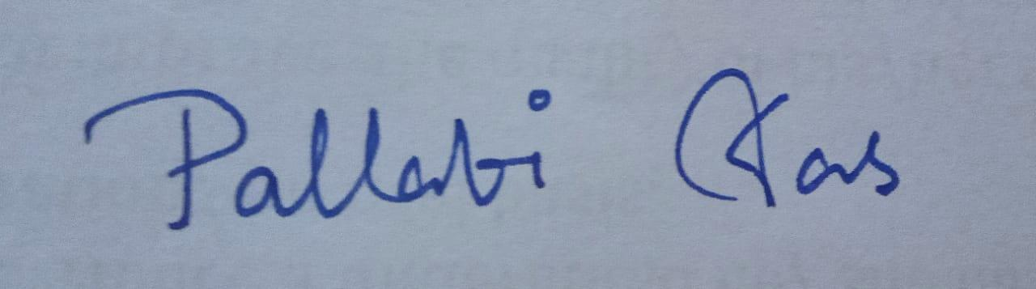

**Pallabi Das**

**Principal**